TASK 18:

* Install Terraform on windows using PowerShell
* Verify if terraform is installed.
* Try to create a resource group using Terraform.

Steps:

Step 1: Write command in powershell: Get-ExecutionPolicy to get execution policy status of powershell.

Now write command, Set-ExecutionPolicy AllSigned to set execution policy to all Signed.

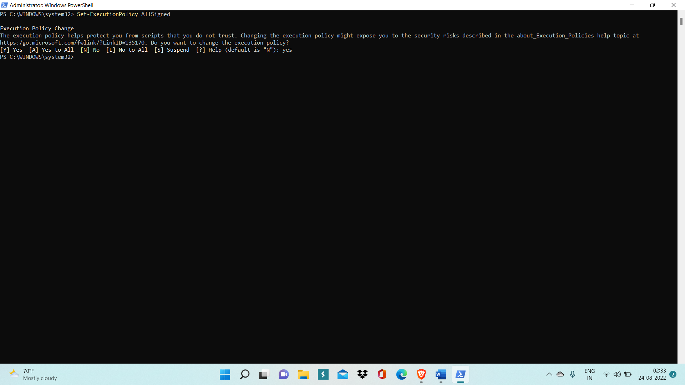

Step 2: Now Run command: Set-ExecutionPolicy Bypass -Scope Process -Force; [System.Net.ServicePointManager]::SecurityProtocol = [System.Net.ServicePointManager]::SecurityProtocol -bor 3072; iex ((New-Object System.Net.WebClient).DownloadString('https://chocolatey.org/install.ps1'))

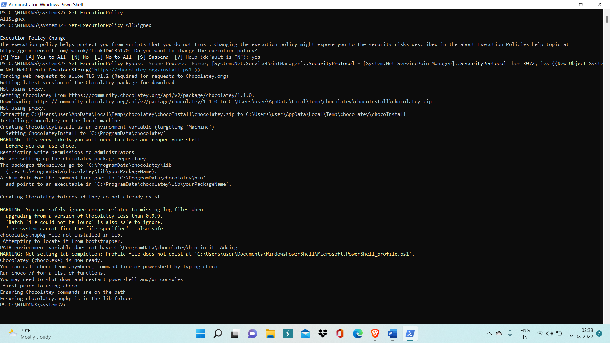

Step 3: Now run command: choco install terraform

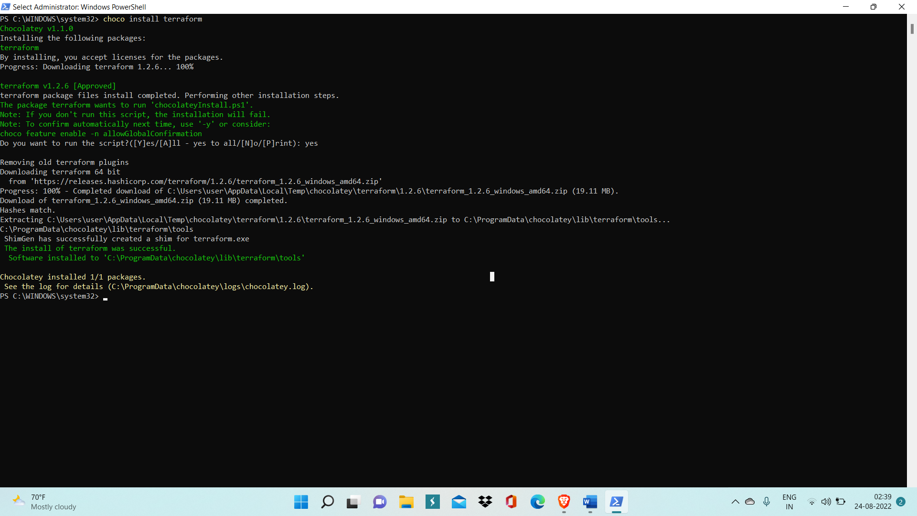

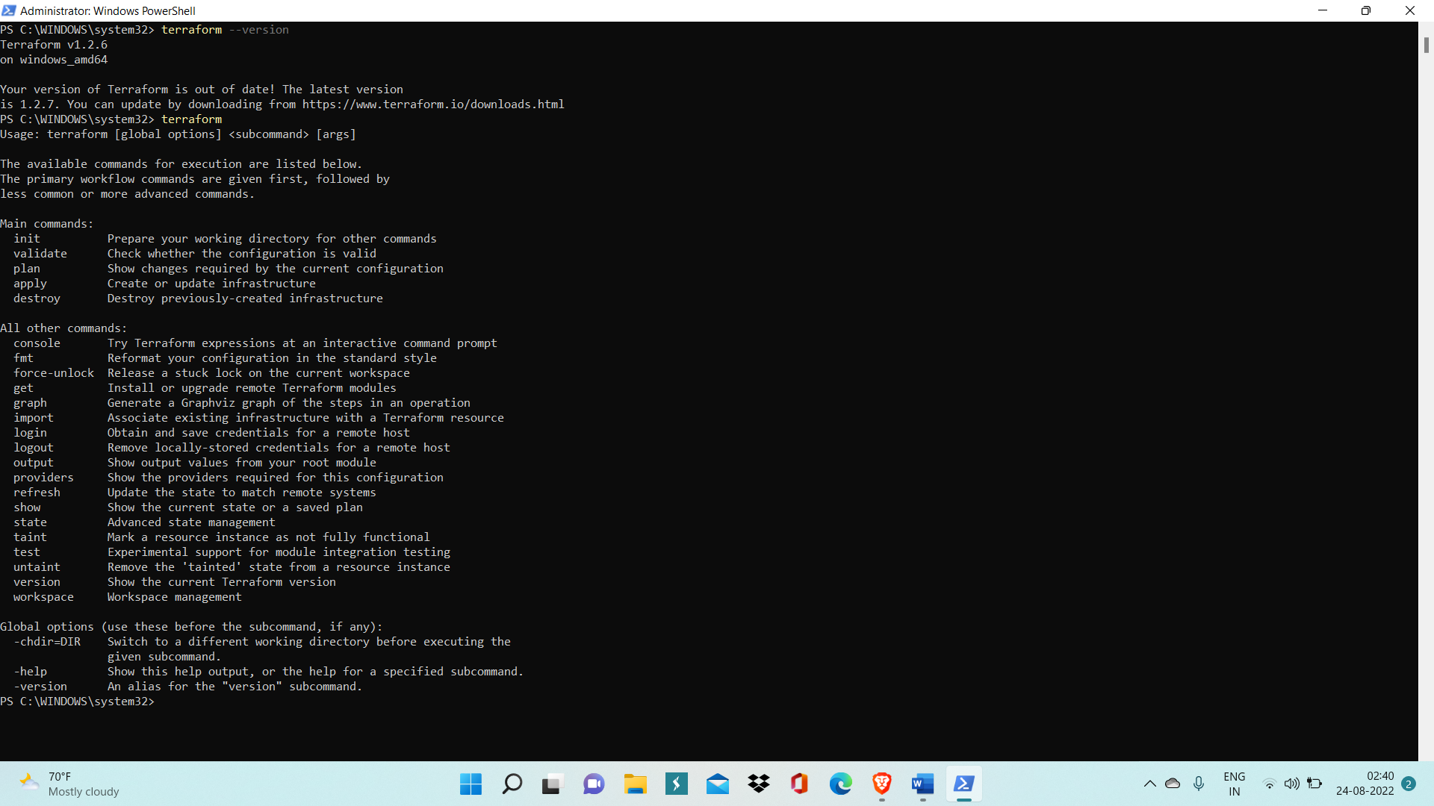

This shows terraform is correctly working on our system.

Step 4: Go to Cloud shell inside Azure Portal and make new directory ‘test001’ and inside it, create a new terraform file ‘main.tf’.

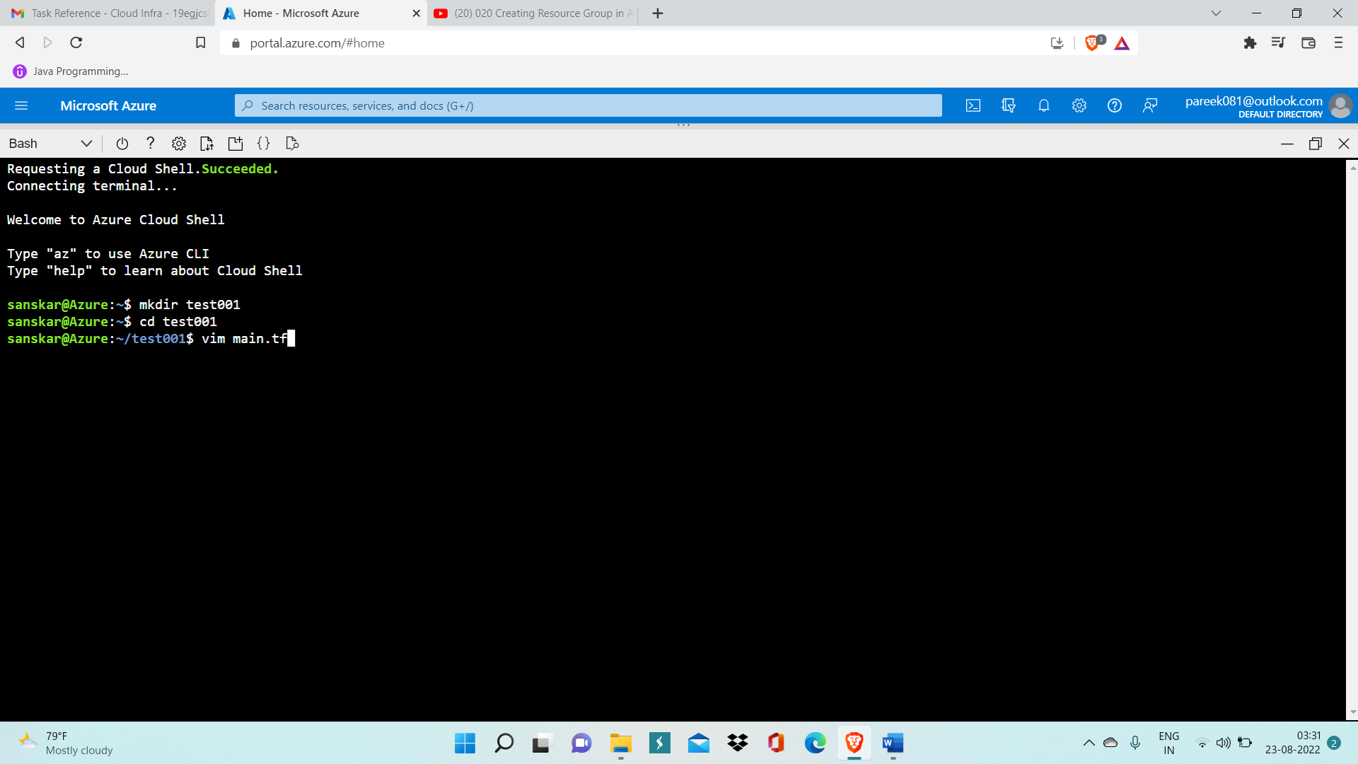

Step 5: Now, open main.tf file in vim editor and provide all details related to resource group.

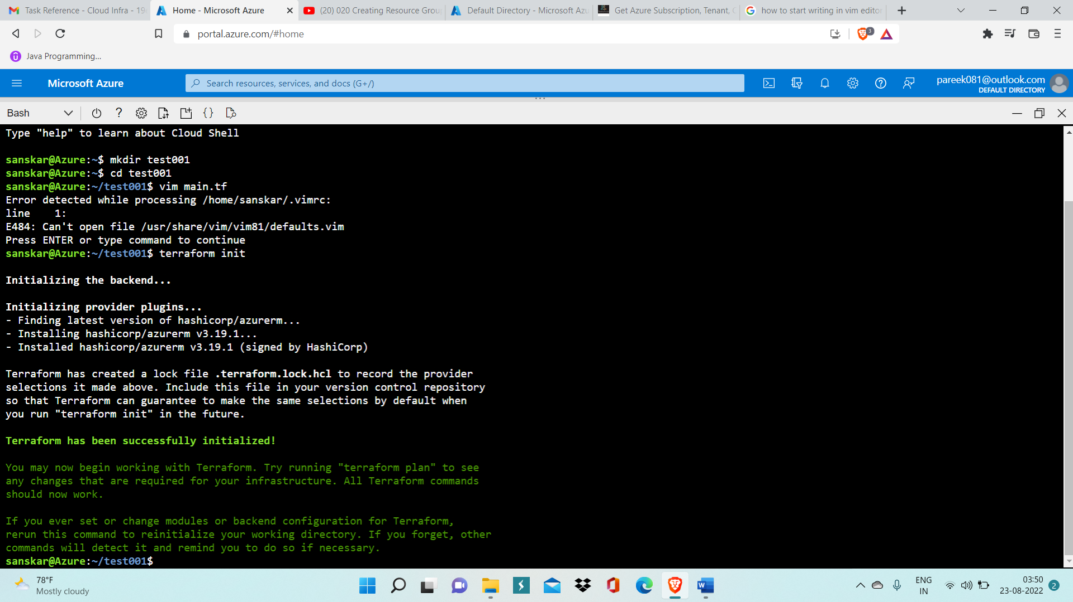

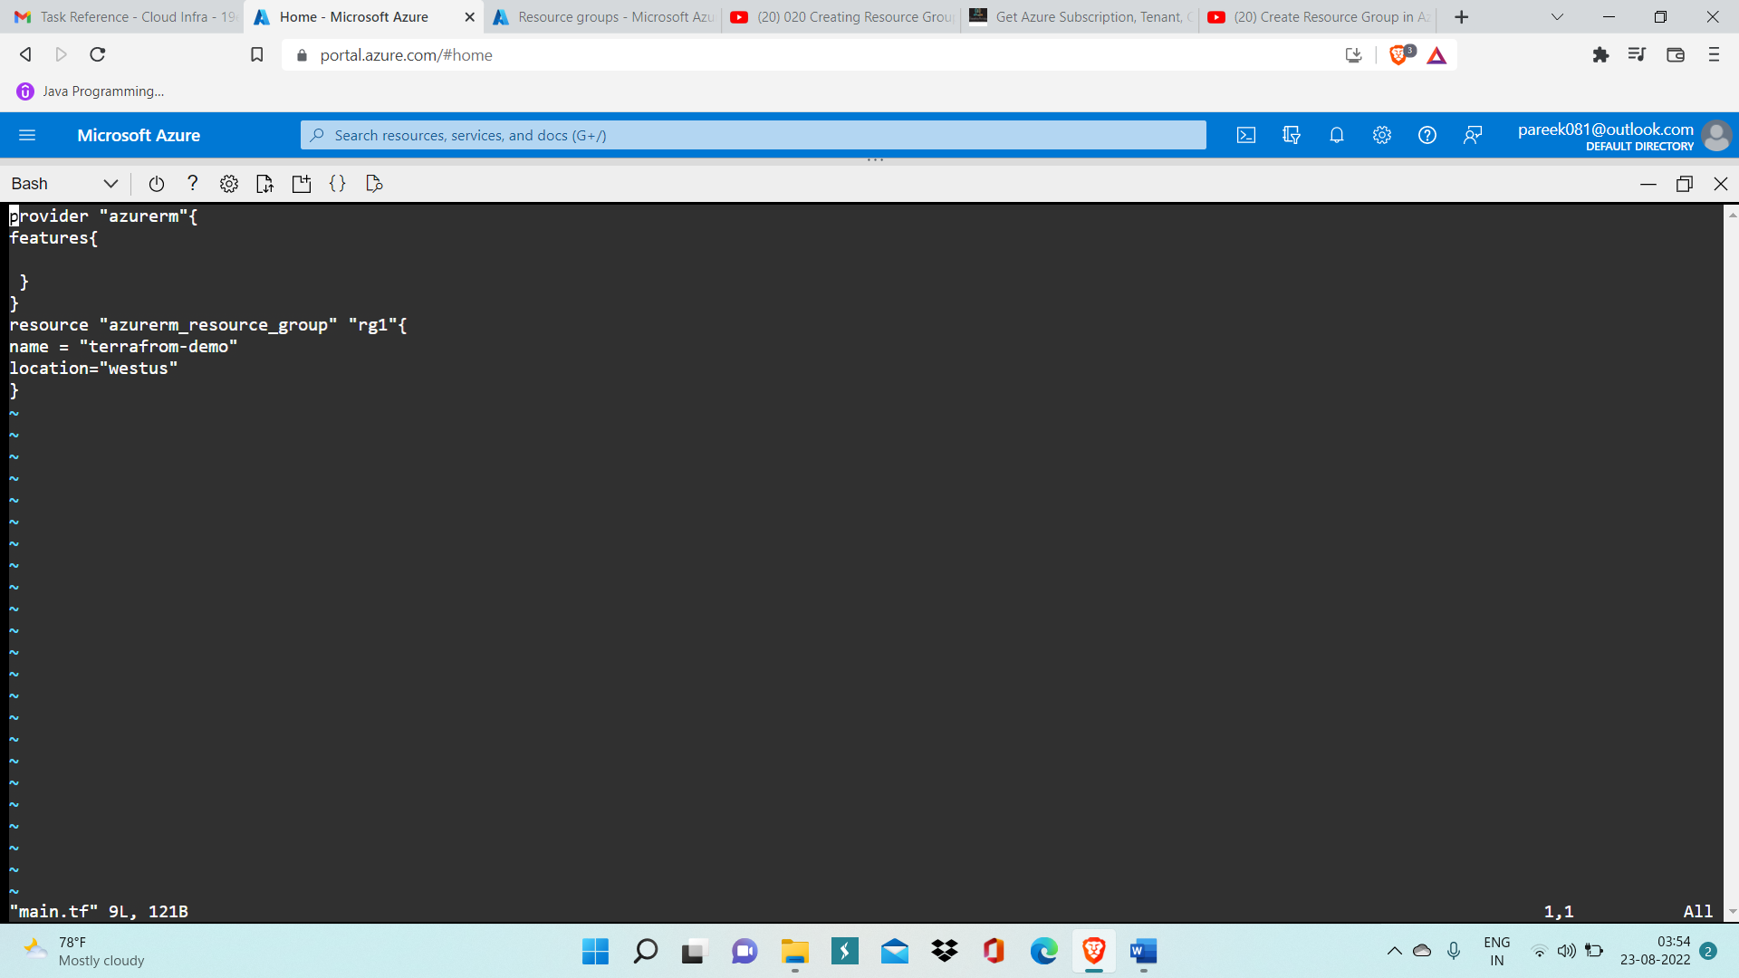

Here, we have created resource group with name ‘terraform-demo’ in west us location

Step 6: Save main.tf file

Step 7: Run command ‘terraform init’ to initialize terraform and then run command ‘terraform validate’ to validate content written inside main.tf file.



Step 8: Run command ‘terraform apply’ to create resource group

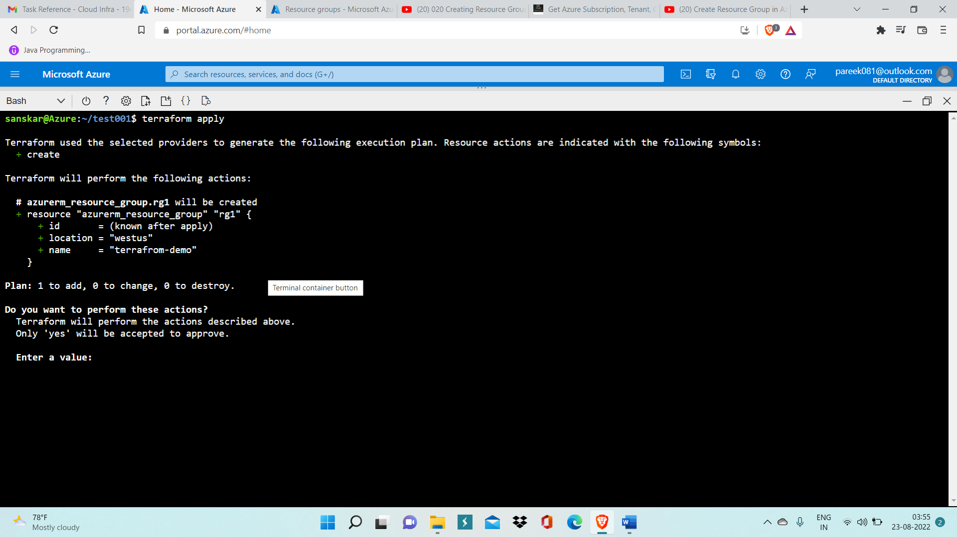

Step 9: Now GO inside Azure Portal, go to Resource group and check ‘terraform-demo’ is present there or not.

